RegistedUser

Image38.png

Nambaby

# Users

Image0.png

## Details

# AdminManageBadPost

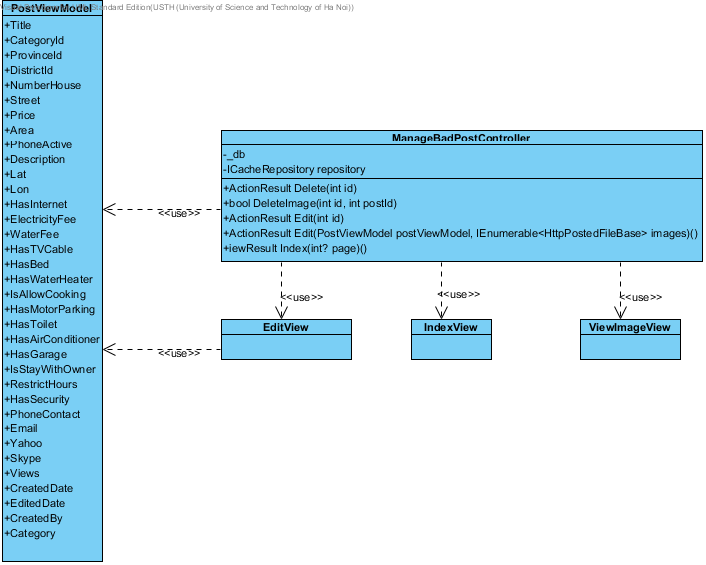

## Details

### Image2.png PostViewModel

### Image2.png ManageBadPostController

### Image2.png EditView

### Image2.png IndexView

### Image2.png ViewImageView

# AdminManageBadWords

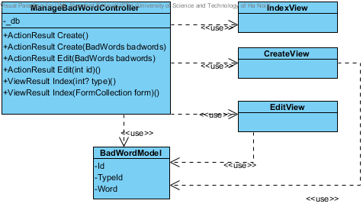

## Details

### Image2.png ManageBadWordController

### Image2.png IndexView

### Image2.png CreateView

### Image2.png EditView

### Image2.png BadWordModel

# AdminManageBadWordType

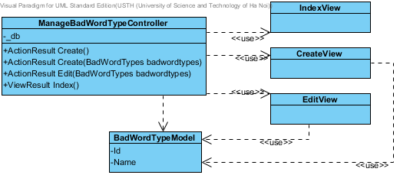

## Details

### Image2.png IndexView

### Image2.png ManageBadWordTypeController

### Image2.png CreateView

### Image2.png EditView

### Image2.png BadWordTypeModel

# AdminManageCategories

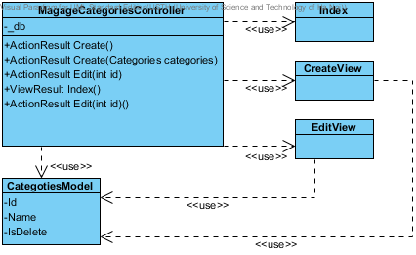

## Details

### Image2.png MagageCategoriesController

### Image2.png Index

### Image2.png CreateView

### Image2.png EditView

### Image2.png CategotiesModel

# AdminManageDistrict

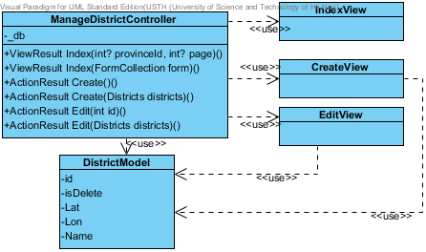

## Details

### Image2.png IndexView

### Image2.png ManageDistrictController

### Image2.png CreateView

### Image2.png EditView

### Image2.png DistrictModel

# AdminManagePost

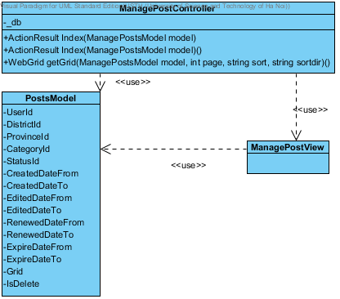

## Details

### Image2.png ManagePostController

### Image2.png PostsModel

### Image2.png ManagePostView

# AdminManagePostStatus

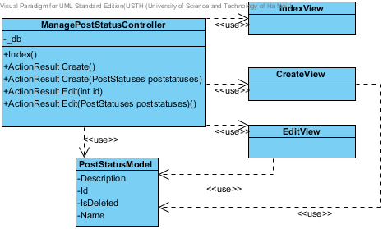

## Details

### Image2.png IndexView

### Image2.png ManagePostStatusController

### Image2.png CreateView

### Image2.png EditView

### Image2.png PostStatusModel

# AdminManageProvince

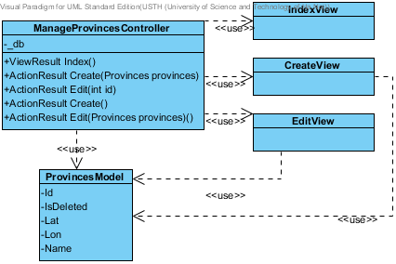

## Details

### Image2.png IndexView

### Image2.png ManageProvincesController

### Image2.png CreateView

### Image2.png EditView

### Image2.png ProvincesModel

# AdminManageReportPost

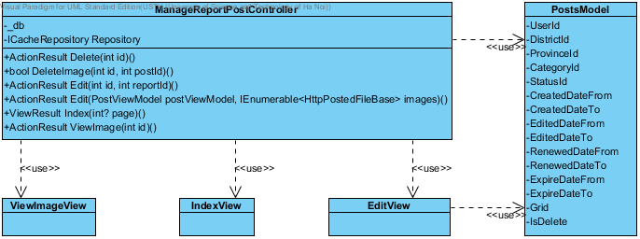

## Details

### Image2.png ManageReportPostController

### Image2.png PostsModel

### Image2.png ViewImageView

### Image2.png IndexView

### Image2.png EditView

# AdminManageRole

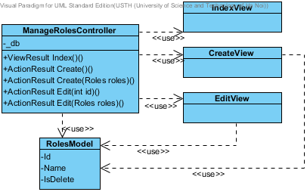

## Details

### Image2.png IndexView

### Image2.png ManageRolesController

### Image2.png CreateView

### Image2.png EditView

### Image2.png RolesModel

# AdminManageRoles

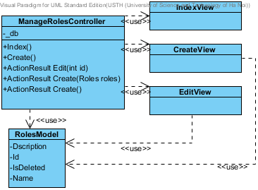

## Details

### Image2.png IndexView

### Image2.png ManageRolesController

### Image2.png CreateView

### Image2.png EditView

### Image2.png RolesModel

# AdminPayment

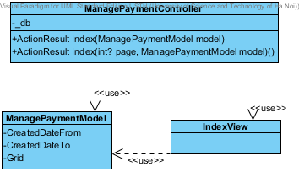

## Details

### Image2.png ManagePaymentController

### Image2.png ManagePaymentModel

### Image2.png IndexView

# AdvanceSearch

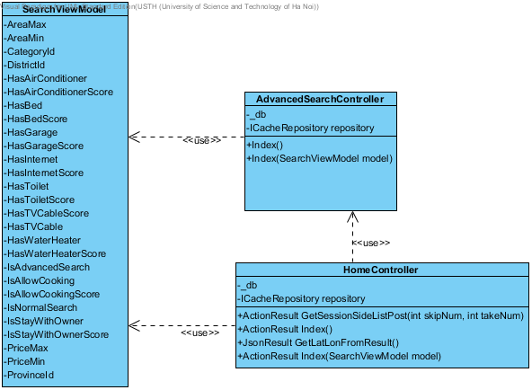

## Details

### Image2.png SearchViewModel

### Image2.png AdvancedSearchController

### Image2.png HomeController

# ChangePassword

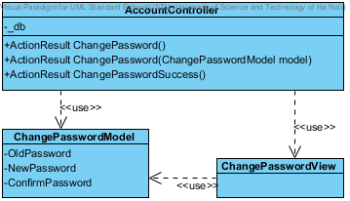

## Details

### Image2.png AccountController

### Image2.png ChangePasswordModel

### Image2.png ChangePasswordView

# Logon_LogOut_Register

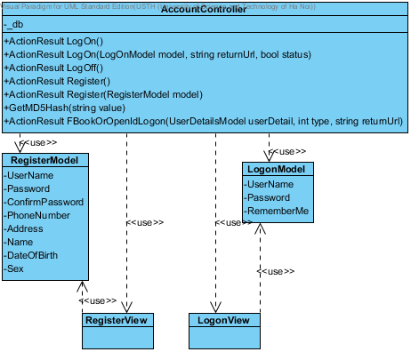

## Details

### Image2.png AccountController

### Image2.png RegisterModel

### Image2.png LogonModel

### Image2.png RegisterView

### Image2.png LogonView

# Post

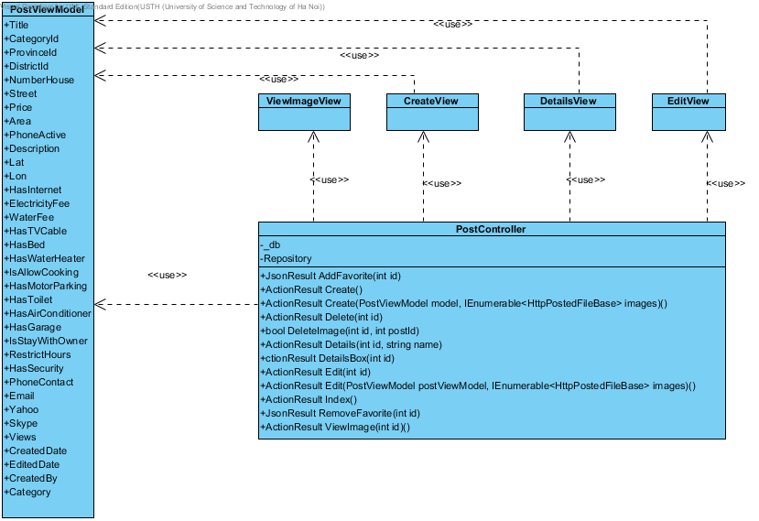

## Details

### Image2.png PostViewModel

### Image2.png ViewImageView

### Image2.png CreateView

### Image2.png DetailsView

### Image2.png EditView

### Image2.png PostController

# QuestionAnswer

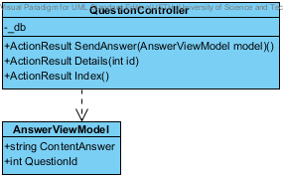

## Details

### Image2.png QuestionController

### Image2.png AnswerViewModel

# Search

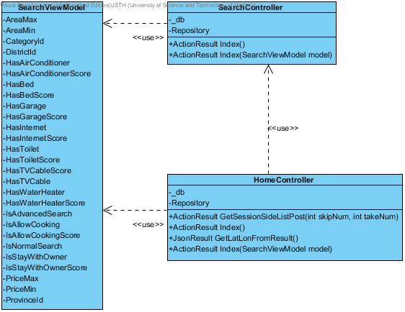

## Details

### Image2.png SearchViewModel

### Image2.png SearchController

### Image2.png HomeController

# UserControlPanel

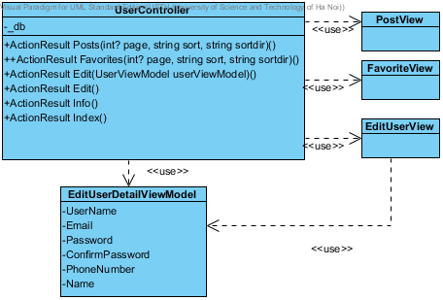

## Details

### Image2.png UserController

### Image2.png PostView

### Image2.png FavoriteView

### Image2.png EditUserView

### Image2.png EditUserDetailViewModel

# AddFavourite

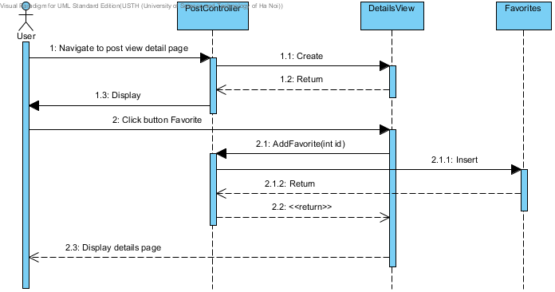

## Details

### Image22.png User

### Image23.png PostController

### Image23.png DetailsView

### Image23.png Favorites

# AdvancedSearch

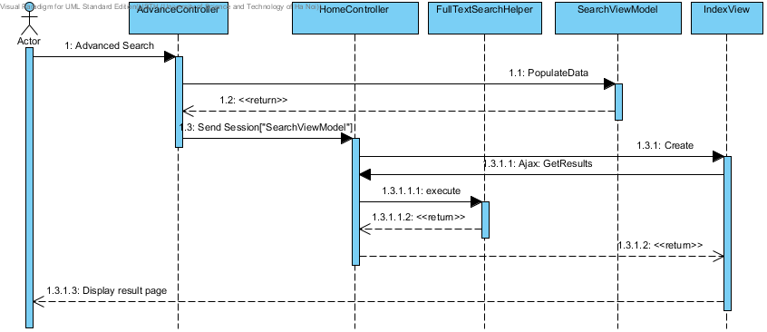

## Details

### Image22.png Actor

### Image23.png AdvanceController

### Image23.png SearchViewModel

### Image23.png HomeController

### Image23.png IndexView

### Image23.png FullTextSearchHelper

# CreateCategory

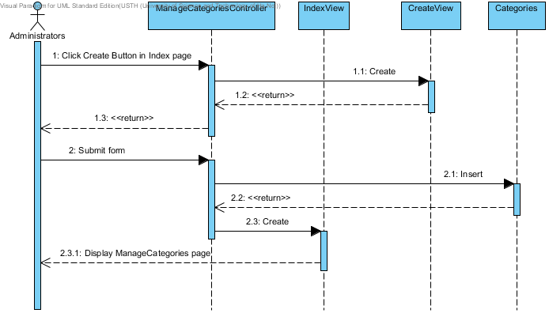

## Details

### Image22.png Administrators

### Image23.png ManageCategoriesController

### Image23.png CreateView

### Image23.png Categories

### Image23.png IndexView

# CreatePost

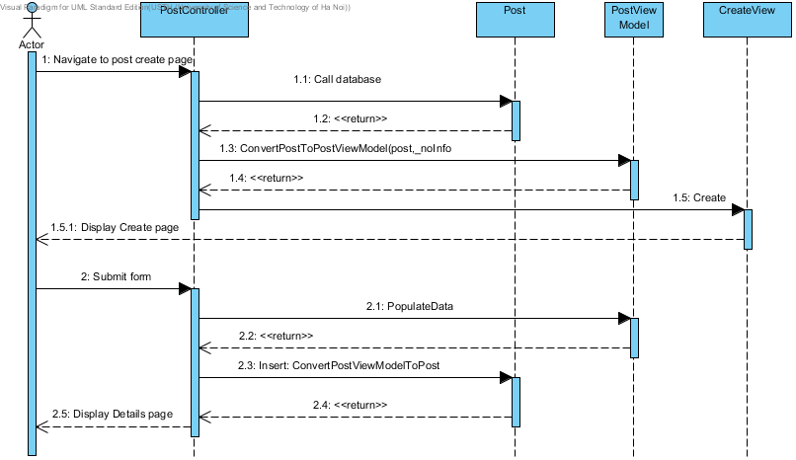

## Details

### Image22.png Actor

### Image23.png PostController

### Image23.png Post

### Image23.png PostViewModel

### Image23.png CreateView

# DeleteFavorite

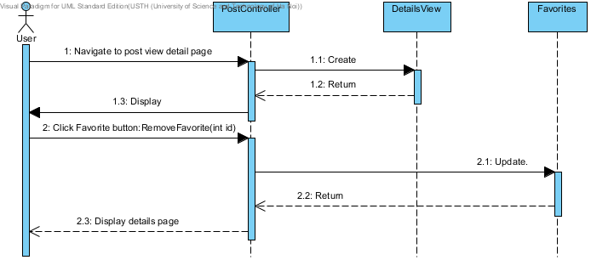

## Details

### Image22.png User

### Image23.png PostController

### Image23.png DetailsView

### Image23.png Favorites

# DeletePost

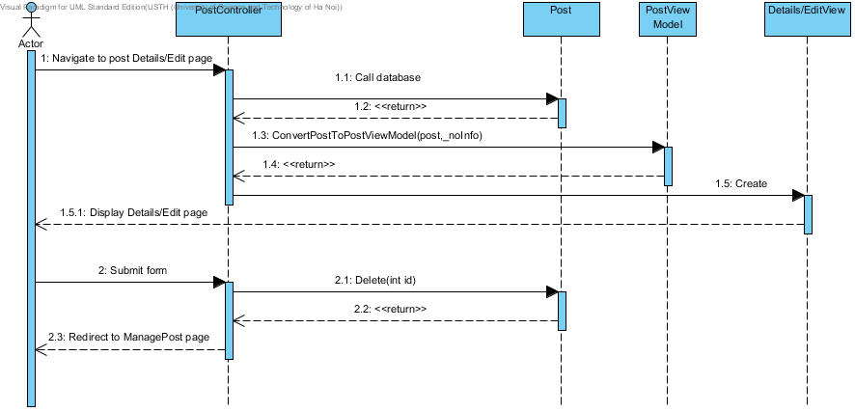

## Details

### Image22.png Actor

### Image23.png PostController

### Image23.png Post

### Image23.png PostViewModel

### Image23.png Details/EditView

# Edit Post

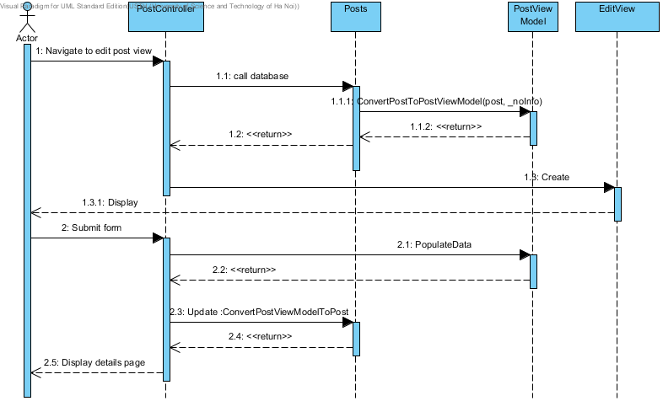

## Details

### Image22.png Actor

### Image23.png PostController

### Image23.png Posts

### Image23.png PostViewModel

### Image23.png EditView

# EditUserInfo

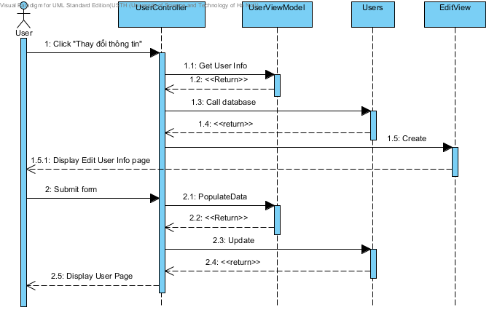

## Details

### Image22.png User

### Image23.png UserController

### Image23.png UserViewModel

### Image23.png Users

### Image23.png EditView

# Login

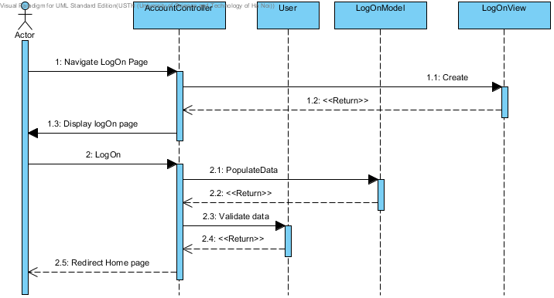

## Details

### Image22.png Actor

### Image23.png AccountController

### Image23.png LogOnView

### Image23.png LogOnModel

### Image23.png User

# ManageFavorite

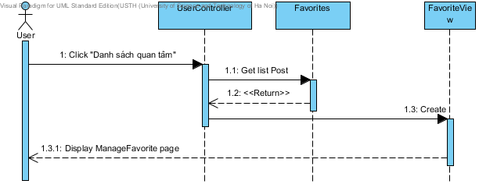

## Details

### Image22.png User

### Image23.png UserController

### Image23.png Favorites

### Image23.png FavoriteView

# Register

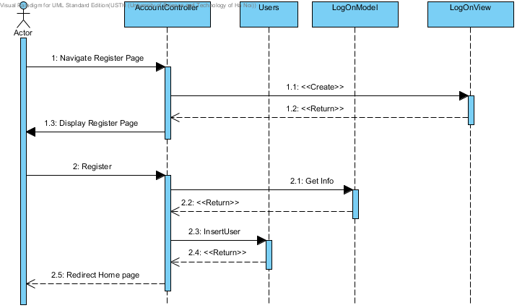

## Details

### Image22.png Actor

### Image23.png AccountController

### Image23.png LogOnView

### Image23.png LogOnModel

### Image23.png Users

# Search

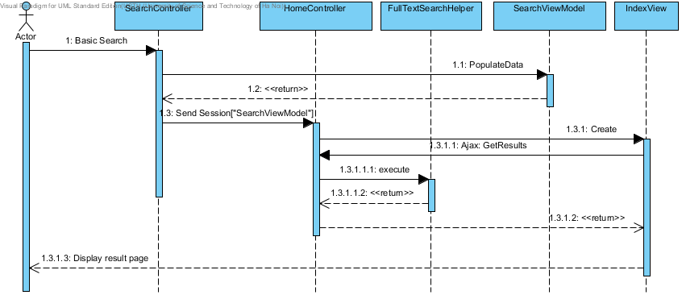

## Details

### Image22.png Actor

### Image23.png SearchController

### Image23.png SearchViewModel

### Image23.png HomeController

### Image23.png IndexView

### Image23.png FullTextSearchHelper

# UserManagePost

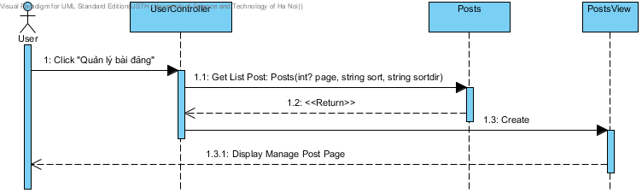

## Details

### Image22.png User

### Image23.png UserController

### Image23.png Posts

### Image23.png PostsView

# ViewPost

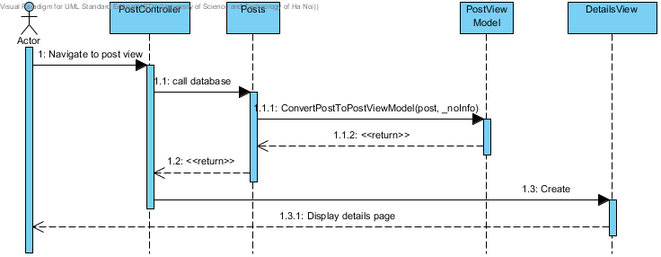

## Details

### Image22.png Actor

### Image23.png PostController

### Image23.png Posts

### Image23.png PostViewModel

### Image23.png DetailsView

# ViewUserInfo

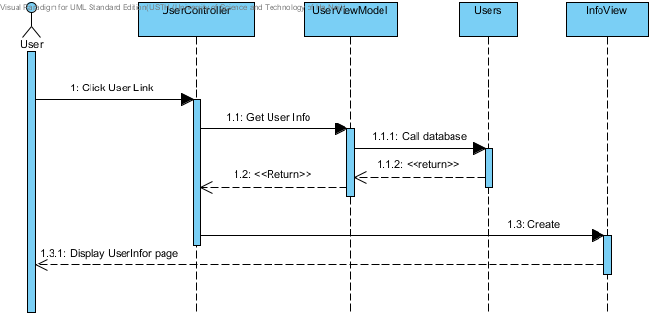

## Details

### Image22.png User

### Image23.png UserController

### Image23.png UserViewModel

### Image23.png Users

### Image23.png InfoView